**EduFlex: ADAPTIVE ONLINE LEARNING PLATFORM TO ENHANCE PRIMARY EDUCATION**

2023-24-091

B.Sc. (Hons) Degree in Information Technology

(Specialization in Data Science)

Department of Information Technology

Sri Lanka Institute of Information Technology

Sri Lanka

April 2024

**EduFlex: ADAPTIVE ONLINE LEARNING PLATFORM TO ENHANCE PRIMARY EDUCATION**

2023-24-091

The dissertation was submitted in partial fulfilment of the requirements

for the B.Sc. Special Honors degree in Information Technology

(Specialization in Data Science)

Department of Information Technology

Sri Lanka Institute of Information Technology

Sri Lanka

April 2024

# DECLARATION

I declare that this is my own work, and this proposal does not incorporate without acknowledgment any material previously submitted for a degree or diploma in any other university or Institute of higher learning, and to the best of my knowledge and belief it does not contain any material previously published or written by another person except where the acknowledgment is made in the text.

|  |  |  |
| --- | --- | --- |
| Name | Student ID | Signature |
| Wijesundara W.M.P.S | IT20644512 |  |
| Hapuarachchi H.D.I.C. | IT20617264 |  |
| Jayasekara J.A.Y.V. | IT20645748 |  |
| Samarakkody G.K.G.D.A | IT20619558 |  |

The above candidate is carrying out research for the undergraduate Dissertation under my supervision.

Signature of the supervisor Date

05/04/2024

(Mr. Samadhi Rathnayake)

# ABSTRACT

This research presents an innovative adaptive learning system tailored specifically for primary school students. Through a multi-faceted approach, this system integrates cutting-edge technologies and methodologies to address key challenges in primary education. The purpose of this study is to develop a comprehensive adaptive online learning platform that encompasses facial authentication, addressing emotional weaknesses, personalized recommendation systems, and real-time attentiveness monitoring. Firstly, a novel facial authentication system is introduced to streamline login processes and enhance the user experience by leveraging facial recognition technology, including Vision Transformers (ViT), Face Transformers, and established Convolutional Neural Networks (CNNs) like VGGFace2, FaceNet, and MobiFace. Secondly, the system incorporates a framework for classifying emotions in primary school children, augmented by a reinforcement learning (RL) model, and utilizing the cutting-edge transformer model Bidirectional Encoder Representations from Transformers (BERT). This framework aims to assist students in identifying true emotions and provides teachers with informed guidance on addressing emotional challenges. Thirdly, a recommendation system is developed to improve students' educational outcomes by administering subject-specific and general knowledge quizzes and offering tailored suggestions based on performance data and machine learning algorithms, such as knowledge graphs and transfer learning techniques. Lastly, the study proposes a unique approach to monitoring students' attentiveness in real-time during online quizzes using machine learning methods, including a pre-trained MobileNet model for transfer learning and real-time video processing algorithms. The significance of this research lies in its potential to revolutionize primary education by providing educators with powerful tools to support personalized learning and emotional growth. This adaptive learning system has far-reaching positive outcomes for the future of education, promoting inclusivity, engagement, and academic success for all primary school students.

**Keywords**—Adaptive online learning system, Emotion classification, Facial authentication, Real-time attention monitoring, Recommendation system

# ACKNOWLEDGMENT

We extend our heartfelt gratitude to Mr. Samadhi for his exceptional guidance and mentorship as our supervisor throughout this research endeavor. His profound expertise and insightful direction have played a pivotal role in shaping the trajectory and outcomes of this study.

We are deeply appreciative of Dr. Dharshana for his unwavering support and invaluable contributions as our co-supervisor. His astute guidance and encouragement have been indispensable in navigating the complexities inherent in this research project.

We would like to express our sincere thanks to Dr. Junius and Dr. Lakmini from the esteemed research panel for their valuable insights and recommendations. Their constructive feedback and suggestions for enhancing the model have significantly contributed to its refinement and advancement. Furthermore, we would like to thank our lecturer in charge, Dr. Jayantha Amararachchi, and the CDAP team for their assistance in ensuring the project's success.

Special appreciation is extended to Dr. Indika Wijerathna, a distinguished psychologist, whose collaboration and expertise were instrumental in understanding and delineating the emotions to be captured from primary students. Additionally, we are grateful to Mrs. Inoka Ekanayake, an esteemed English teacher, for her valuable input in crafting questions that effectively elicit a diverse range of emotions from students.

We are profoundly grateful for the support, guidance, and expertise provided by these individuals throughout this research journey. Their contributions have enriched the depth and quality of this work, and we are privileged to have had the opportunity to collaborate with such esteemed professionals.

# TABLE OF CONTENT

**DECLARATION i**

**ABSTRACT iii**

**ACKNOWLEDGMENT iv**

**TABLE OF CONTENT v**

**LIST OF FIGURES vii**

**TABLE OF ABBREVIATIONS viii**

**LIST OF TABLES viii**

**1. INTRODUCTION 1**

**1.1 Background and Literature 1**

**1.2 Research Gap 3**

**1.3 Research Problem 7**

**1.4 Research Objectives 8**

**1.4.1 Main Objectives 8**

**1.4.2 Specific Objectives 9**

**2. METHODOLOGY 11**

**2.1 Data Collection 11**

**2.2 System Architecture 12**

**2.3 Tools and Technologies 15**

**2.4 Implementation 16**

**2.4.1 Facial Authentication for Adaptive Online Learning platform for primary students 16**

**2.4.2 Personalized Emotional Weaknesses Addressing Model​ 26**

**2.4.3 Recommendation System for Improve Primary Students Educational Performance 37**

**2.4.4 Real – time attention monitoring system for enhancing educational performance 49**

**3. COMMERCIALIZATION 58**

**Target Market 58**

**Revenue Streams 58**

**Marketing Approach 58**

**4. RESULTS AND DISCUSSION 60**

**4.1 Results 60**

**Facial Authentication for Adaptive Online Learning Platform for Primary Students 60**

**Personalized Emotional Weaknesses Addressing Model​ 63**

**Recommendation System for Improve Primary Students Educational Performance 66**

**Real – time attention monitoring system for enhancing educational performance 71**

**4.2 Research Findings 73**

**4.3 Discussion 76**

**5. CONCLUSION 79**

**6. REFERENCES 82**

# LIST OF FIGURES

Figure 1: Sample data 12

Figure 2: Overall System Architecture 14

Figure 3: Implementation of ViT approach. 18

Figure 4: Implementation of ViT facial recognition class. 19

Figure 5: Implementation of CNN approach. 20

Figure 6: Implementation of CNN Model Architecture. 20

Figure 7: Implementation of CNN approach loss function 21

Figure 8: Auto Login Function and Login endpoint creation backend Flask 22

Figure 9: Register New Users 23

Figure 10: Register New Users using Admin, Store Face embeddings 24

Figure 11: Loading Pre-trained Model and Tokenizer 28

Figure 12: Tokenizing Sentences 28

Figure 13: Converting Tokenized Data into Tensors 28

Figure 14: Creating Data Loaders 29

Figure 15: Values for Hyperparameter Tuning 29

Figure 16: Evaluation Function 29

Figure 17: BERT Training Loop 30

Figure 18: Fine Tuning BERT Model with Optimized Hyperparameters 30

Figure 19: Training the BERT Model and Evaluate on Validation Dataset 31

Figure 20: Evaluate the Model on Test Datasets 31

Figure 21:Defining State and Action Space 32

Figure 22: Initializing Q-Table 32

Figure 23: Setting Hyperparameters 32

Figure 24: Defining Policy Function 33

Figure 25: Defining Q-Learning Algorithm 33

Figure 26: Defining function to access LLM 33

Figure 27: Specifying Training Parameters 34

Figure 28: RL Agent Training Loop 34

Figure 29: Updating Q-Table based on Feedback Given by The Developer 34

Figure 30: Evaluating Agent on Sample Evaluation Data 35

Figure 31: RL Agent Evaluation 35

Figure 32: Overview of Recommendation System 39

Figure 33: NER Model 1 40

Figure 34: NER Model 2(Save custom model) 41

Figure 35: Knowledge Graph construct 42

Figure 36: Visualize Knowledge Graph 42

Figure 37: Pre-train graph-embedding model 43

Figure 38: generate recommendations function 44

Figure 39: add_entity_relationships function 45

Figure 40: handleSubmit function 45

Figure 41: Evaluate answers 46

Figure 42: Define educational levels 46

Figure 43: Import Libraries for model implementation 50

Figure 44:Load the dataset and Preprocessing. 50

Figure 45: Model defining image 1 51

Figure 46: Model defining image 2 51

Figure 47: Reshape and add output layer 51

Figure 48: Freeze the weights. 52

Figure 49: Compile the model. 52

Figure 50: Early stopping callback function. 52

Figure 51: Terminate the model training. 52

Figure 52: layers in base model 53

Figure 53: Start model fine-tuning. 53

Figure 54:View model summary 53

Figure 55: Training the fine-tuned model. 54

Figure 56:Evaluate model for test batches. 54

Figure 57:loading test images 1 54

Figure 58: Loading test images 2 55

Figure 59: Predict test images. 55

Figure 60: Confusion Matrix for model 55

Figure 61: Classification Report of Naive Bayes Model 63

Figure 62: Confusion Matrix of Naive Bayes Model 64

Figure 63: Validation Accuracy of BERT Model 64

Figure 64: Classification Report of BERT Model 64

Figure 65: Confusion Matrix of BERT Model 65

Figure 66: Training RL Agent 66

Figure 67: Updated Q-Table 66

Figure 68: Classification report for custom NER model 67

Figure 69: Knowledge graph 69

Figure 70: Entity availability 69

Figure 71: Generated Recommendations 70

Figure 72: Before fine - tuning the model. 71

Figure 73: Before fine - tuning the model accuracy. 72

Figure 74: After fine-tuning the model matrix 72

Figure 75: Model after fine-tuning accuracy. 73

Figure 76: Confusion matrix for the model 73

# TABLE OF ABBREVIATIONS

|  |  |
| --- | --- |
| **Abbreviation** | **Long Form** |
| BERT | Bidirectional Encoder Representations from Transformers |
| RL | Reinforcement Learning |
| LLM | Large Language Model |

# LIST OF TABLES

Table 1: Tools and Technologies 24

# 1. INTRODUCTION

## 1.1 Background and Literature

In the rapidly evolving landscape of education, the integration of technology has become increasingly vital, particularly in the context of online learning platforms. The COVID-19 pandemic has further accelerated this shift, making remote education a necessity rather than an option [1]. This transition has brought to light unique challenges, especially for primary-level students who are still developing foundational skills, including cognitive abilities, emotional intelligence, and basic digital literacy.

One significant challenge in online learning is secure and user-friendly authentication. Traditional methods such as passwords can be cumbersome and insecure, especially for younger students [2]. A study by Smith et al. [3] highlights that primary students often struggle with remembering complex passwords, leading to frequent account lockouts or the use of overly simple, insecure passwords. Facial authentication emerges as a promising solution, offering a seamless and secure way for young learners to access their educational resources. Research by Johnson and Lee [4] demonstrates that facial recognition can achieve up to 98% accuracy, making it a reliable alternative to traditional login methods.

Another critical aspect of primary education is the development of emotional intelligence (EI). EI plays a crucial role in academic performance, social interactions, and overall well-being [5]. However, the shift to online learning has made it challenging for educators to gauge and foster students' emotional states. Adaptive quizzes present an innovative approach to address this gap. A study by Fernández-Berrocal et al. [6] found that interactive, game-like assessments can effectively measure and improve EI in children. These adaptive quizzes adjust their difficulty and content based on the child's responses, providing a personalized learning experience.

Personalization is indeed key in online education, particularly for primary students whose learning needs can vary greatly. This is where recommendation systems come into play. By leveraging knowledge graphs, these systems can provide tailored educational content, enhancing learning outcomes. A knowledge graph, as described by Bizer et al. [7], is a network of entities, their semantic types, properties, and relationships. In the educational context, Wang and Tao [8] demonstrate how knowledge graphs can map concepts, skills, and their interdependencies, allowing for the creation of personalized learning paths.

A seminal paper by Chen et al. [9] introduces an adaptive learning system for primary mathematics that uses a knowledge graph to understand each student's strengths and weaknesses. The system then recommends specific exercises, videos, or games to address identified gaps. Their results show a 25% improvement in test scores compared to traditional methods. Similarly, a study by Rodriguez et al. [10] in language learning found that knowledge graph-based recommendations led to a 30% increase in vocabulary retention among primary students.

However, it's important to note that while these technologies offer immense potential, their implementation must be thoughtful and age-appropriate. Privacy concerns with facial recognition [11] and the need for transparent, explainable AI in education [12] are critical considerations. Moreover, as Piaget's theory of cognitive development suggests [13], primary students are in a concrete operational stage, necessitating interactive, tangible learning experiences even in digital environments.

In summary, the landscape of primary education is being reshaped by adaptive online learning platforms. Facial authentication offers a secure and user-friendly login experience, adaptive quizzes cater to the crucial development of emotional intelligence, and knowledge graph-based recommendation systems provide personalized learning pathways. These components collectively address the unique challenges of online learning for young students. However, their implementation must prioritize privacy, transparency, and age-appropriate design to truly enhance educational outcomes and foster holistic development.

## 1.2 Research Gap

The landscape of adaptive online learning platforms for primary education is rapidly evolving, yet existing research reveals significant gaps in addressing the unique challenges faced by young learners. Current studies primarily focus on higher education settings, overlooking the developmental nuances of primary students. This oversight is evident in four critical areas: authentication, emotion detection, personalized learning recommendations, and attention monitoring.

First, despite advancements in facial recognition technology across various sectors like security and smartphone authentication, its application in primary education remains underexplored. Traditional username-password systems are cumbersome and insecure for young learners, leading to frustration and wasted instructional time. Simplified alternatives like picture-based passwords still demand cognitive efforts beyond their developmental stage. In adaptive learning platforms, accurate student identification is crucial for tracking progress and adjusting difficulty levels. Yet current solutions rely on cumbersome teacher inputs or simple user profiles prone to mix-ups, especially in remote learning environments. There's a pressing need for seamless, age-appropriate authentication methods like facial recognition to enhance accessibility, engagement, and the effectiveness of personalized learning for primary students.

Second, emotion detection and personalized advice generation using reinforcement learning (RL) and large language models (LLMs) have not been adequately tailored for primary students. Current techniques, often focused on textual data, facial expressions, or speech of adults, overlook children's limited language proficiency and subtle, age-specific emotional expressions. While RL and LLMs show promise in generating personalized advice, their integration into adaptive learning systems for primary students' emotional needs remains underexplored. Specific challenges include mapping emotional states to appropriate interventions and handling the complexity of learner-system interactions. Additionally, ethical considerations, privacy concerns, and the long-term impact of these systems on children's emotional well-being, academic performance, and overall development are critical yet understudied areas. Most research focuses on technical aspects in controlled settings, neglecting the practical challenges of scaling and deploying these systems in real-world primary school environments.

Third, recommendation systems in e-learning contexts have largely neglected primary education. Existing research primarily focuses on post-hoc analysis of test scores rather than real-time monitoring of learning progress. While some studies use AI techniques for recommendations, they either lack specific methodologies or limit their scope to higher education. The few that touch on early childhood education concentrate on AI's impact on cognitive skills like computational thinking or creativity, rather than personalized learning pathways. Furthermore, when recommendations are provided, they often lack transparency in explaining why and how these suggestions are made. This gap underscores the need for a knowledge-based recommendation system tailored for primary education that not only monitors real-time educational performance through adaptive quizzes but also employs explainable AI to provide transparent, justifiable recommendations. Such a system would foster trust among educators, parents, and students, ensure fairness, and significantly enhance the personalized learning experience for young learners.

Lastly, attention monitoring during online quizzes for elementary students is an underexplored area. Existing research on student attention monitoring during online learning primarily focuses on broad scenarios using standard computer vision or shallow machine learning models. These systems struggle with occlusions, varied lighting conditions, and different viewing angles common in home settings. They also neglect the interplay of physical, emotional, and contextual factors influencing a child's attention, resulting in incomplete assessments. Most systems provide delayed or post-hoc analysis, hindering real-time interventions crucial for maintaining engagement during assessments. Furthermore, the majority of studies target adult learners or higher education, disregarding the distinct developmental characteristics and behavior patterns of elementary children. For instance, children's attention spans, facial expressions, and behavioral patterns during quizzes may differ significantly from older students or adults.

Addressing these gaps requires a multifaceted, interdisciplinary approach. First, integrating facial recognition as a seamless, secure authentication method tailored for young learners, considering their cognitive abilities and privacy needs. Second, developing emotion detection techniques that account for the unique emotional expressions and limited verbal abilities of primary students, and integrating these with RL and LLMs to generate age-appropriate, personalized emotional support. This process must adhere to strict ethical guidelines and prioritize long-term emotional well-being.

Third, creating a knowledge-based recommendation system that not only tracks real-time educational performance through adaptive quizzes but also employs explainable AI to provide transparent, justifiable recommendations. This system should consider the child's learning style, pace, and interests, fostering a sense of agency and motivation. Finally, employing deep learning and transfer learning techniques, like fine-tuning pre-trained models on datasets of children's facial expressions and attention labels, to provide robust, real-time attention monitoring during online quizzes. This approach would enable educators to make timely adjustments and interventions, enhancing the effectiveness and engagement of online assessments for young learners.

Furthermore, longitudinal studies are needed to assess the long-term impact of these adaptive systems on children's emotional well-being, academic performance, and overall development. Research should also address the challenges of scaling and deploying these systems in diverse real-world primary school environments, considering factors such as infrastructure requirements, teacher training, and integration with existing learning management systems.

In conclusion, the development of a truly effective adaptive online learning platform for primary education requires bridging significant research gaps. By integrating facial recognition for seamless authentication, tailoring emotion detection and advice generation techniques for young learners, developing transparent, knowledge-based recommendation systems, and employing deep learning for real-time attention monitoring, we can create a holistic, child-centric platform. Such a system would not only enhance educational outcomes but also foster emotional well-being, digital literacy, and a love for learning among primary students, setting a strong foundation for their educational journey.

## 1.3 Research Problem

In the rapidly evolving landscape of primary education, the shift towards digital learning platforms has been accelerated by global events such as the COVID-19 pandemic. However, this transition has exposed significant gaps in addressing the unique developmental, emotional, and cognitive needs of primary-level students. Traditional online learning platforms often treat young learners as miniature adults, overlooking their distinct challenges in user authentication, emotional well-being, personalized learning, and attention management.

The digital divide is particularly stark for primary students who struggle with traditional username-password systems, leading to frustration and wasted learning time. Moreover, these platforms frequently neglect the critical role of emotional intelligence in academic success, offering a one-size-fits-all approach that fails to nurture individual emotional growth. The lack of real-time, personalized educational guidance further hinders their progress, as does the absence of mechanisms to monitor and enhance their attention spans, which are naturally shorter and more volatile than those of older learners.

These gaps not only impede immediate learning outcomes but also risk long-term consequences, including disengagement from education, underdeveloped emotional coping skills, and learning deficits that could persist throughout their academic journey. Therefore, the primary research problem this project aims to address is:

"How can we create an adaptive online learning platform that holistically caters to the unique developmental, emotional, and cognitive needs of primary-level students, ensuring secure and seamless access, personalized emotional and academic support, and enhanced attention management, thereby fostering a foundation for lifelong learning and well-being?"

To comprehensively address this multifaceted research problem, we have identified four key sub-problems, each tackled by a specific component of our adaptive learning platform:

1. **Authentication Challenge:** "How can we implement a secure, user-friendly authentication system tailored for primary students who struggle with traditional login methods, leveraging advanced facial recognition technologies like Vision Transformers (ViT) to ensure both ease of use and robust security?"

2. **Emotional Intelligence Gap:** "How can we develop an emotionally intelligent system that accurately detects and addresses the emotional weaknesses of primary students through adaptive quizzes and personalized advice, utilizing reinforcement learning and large language models to foster emotional resilience and well-being?"

3. **Personalized Learning Deficit:** "How can we create a knowledge-based recommendation system that not only assesses primary students' real-time educational performance but also provides transparent, explainable AI-driven recommendations to enhance their learning outcomes and engagement?"

4. **Attention Management Dilemma:** "How can we design an attention monitoring system specifically for primary students that uses deep learning and transfer learning to provide real-time feedback and interventions, helping young learners develop crucial attention management skills in digital learning environments?"

By addressing these sub-problems, our research aims to bridge the critical gaps in online primary education, fostering an environment where young learners can thrive academically, emotionally, and cognitively. This holistic approach not only enhances immediate learning outcomes but also lays a strong foundation for future educational success and overall well-being.

## 1.4 Research Objectives

### 1.4.1 Main Objectives

The main objective of our research is to develop an advanced adaptive online learning platform that enhances primary education through the integration of four key components. Below are the component-wise main objectives:

* **Adaptive Learning Tracking System Using Facial Authentication**

Develop a facial dynamics-based user authentication algorithm that is robust and accurate.

* **Addressing Emotional Weaknesses of Primary Students by Giving Personalized Advice**

Identify and address the emotional challenges of students through real-time analysis and personalized advice to support their emotional and cognitive development.

* **Attention Behavior Analytics for Online Exam Practice Environment**

Monitor and enhance students' attention during online learning sessions using real-time feedback mechanisms based on facial analysis and head posture characteristics.

* **Recommendation System to Improve Educational Performance**

The main objective of this application is to develop a recommendation system to enhance primary students' educational performance within an adaptive online platform. Online learning is popular and beneficial, but primary students often face performance challenges.

### 1.4.2 Specific Objectives

In pursuit of our overarching goal to create an advanced adaptive online learning platform, we have defined specific objectives for each of the four key components. These objectives are tailored to address distinct challenges and enhance primary education through innovative technological solutions.

**Adaptive Learning Tracking System Using Facial Authentication**

* Design a mechanism to extract facial dynamics using passive biometrics with minimal user interaction.
* Develop a method to identify facial landmarks in challenging conditions.
* Implement an algorithm to generate a unique search index for each user based on their facial features.
* Develop an error handling algorithm to prevent the creation of multiple search indexes.

**Addressing Emotional Weaknesses of Primary Students by Giving Personalized Advice**

* To design and implement an approach for accurate assessment of emotional states in primary students, combining textual, and visual data.
* To develop a reinforcement learning (RL) algorithm that can effectively map identified emotional states to appropriate interventions or personalized advice.
* To integrate a large language model (LLM) capable of generating tailored advice and recommendations for teachers, based on the emotional needs of individual students.
* To collaborate with psychologists and education experts in creating a comprehensive questionnaire that captures various emotional aspects of primary students' lives, including family background, school life, and social interactions.

**Recommendation System to Improve Educational Performance**

* How we collect students' academic performance more efficiently?
* Which type of questionnaires can be used to monitor students’ performance?
* How to classify educational levels based on the results more accurately?
* How to provide the best and most accurate recommendations based on students' educational performance?

# 2. METHODOLOGY

As discussed in the above sections the overall project is a combination of 4 main components where each of them has its own contribution towards the overall project. These sub-sections discuss and illustrate the approach, the implementation and the testing of the product and the commercialization approach of the product.

## 2.1 Data Collection

As previously mentioned, our project comprises four key components, of which only two require training on datasets. The following outlines the data collection methodology for these two components.

**Personalized Emotional Weaknesses Addressing Model**

Recognizing the absence of datasets tailored for emotion classification among primary students, a concerted effort was undertaken to create a comprehensive dataset. A survey comprising 15 carefully curated questions, spanning three domains – family, school, and friends and relatives – was administered to 25 students. The questions were meticulously crafted with the invaluable guidance of a psychologist and an English teacher, ensuring their relevance and appropriateness. Each question was associated with one of the predefined emotions from the emotion list, including happiness, sadness, fear, feeling loved or unloved. The resulting dataset, comprising 760 records, provided a rich tapestry of emotional responses from the target demographic. This dataset proved instrumental in training a BERT model specifically tailored for emotion classification, enabling it to accurately interpret and categorize the emotional undertones present in the responses provided by users through the website.

**Real – time attention monitoring system for enhancing educational performance.**

For attention monitoring, dataset is collected from 350 students in grade 2,3,4 and 5 at the WP/JAYA Kottawa North Dharmapala Vidayala Hokandara. The collection of the data was conducted with permission of Deputy Principal Mrs. K.L.A Priyalatha.

Permission Letter:

<https://drive.google.com/file/d/1hO2st4qj3XADjgoFNdirR-A7o0zo_aZL/view?usp=sharing>

The images were collected using webcams set up in the students’ learning environment. The dataset contains a diverse range of facial expressions, head positions and viewing angles.

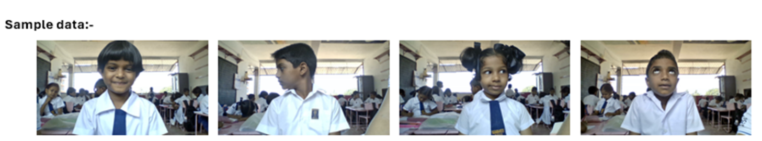

Figure 1: Sample data

## 2.2 System Architecture

The system architecture, illustrated below, embodies the core of this research project. The primary objective is to develop an adaptive learning platform specifically tailored for primary-level students. This platform leverages machine learning and personalized recommendations to enhance authentication, emotional well-being, attention monitoring, and educational performance. The system aggregates data from multiple sources, including facial authentication, emotional assessments, and attention monitoring, as depicted in the diagram.

Subsequently, a machine learning approach is devised to provide individualized educational and emotional support based on the student's needs. These interventions are meticulously customized to align with each student's preferences and learning style, offering a highly efficient method to improve engagement and academic success.

To ensure the platform's effectiveness and user-friendliness, the application’s performance is assessed through thorough user testing and cross-validation. The overall goal of the project is to create an adaptive learning environment that is accurate, personalized, and supportive of primary-level students' educational and emotional needs.

The proposed solution aims to create an adaptive learning platform tailored for primary-level students. The system will comprise four main components:

1**. Facial Authentication** - Replace traditional login systems with facial authentication to accommodate young students who may struggle with usernames and passwords.

2. **Addressing Emotional Weaknesses through Personalized Advice** - Identify and address emotional weaknesses to improve motivation, engagement, and academic success.

3. **Recommendation System for Improving Educational Performance** - Offer actionable recommendations to help students enhance their educational performance, beyond just quizzes and results.

4**. Attention Monitoring System** - Help students improve their focus and attention on given tasks.

The initial three components will ensure secure login, assess emotional well-being, and gauge educational performance. The fourth component will utilize the data generated by the first three components to offer suggestions for improving attention and personalized learning recommendations through an integrated desktop application.

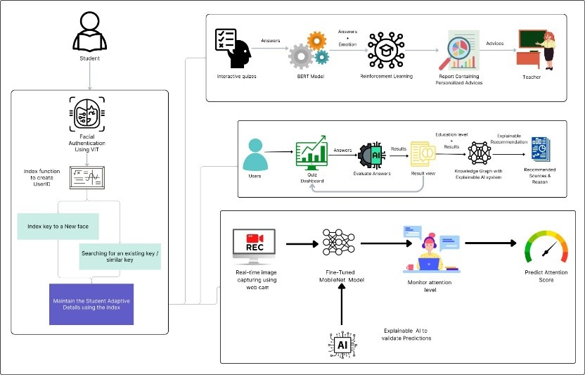

Figure 2: Overall System Architecture

## 2.3 Tools and Technologies

The table below contains a full summary of the technology and tools used to create the program and the application.

Table 1: Tools and Technologies

|  |  |
| --- | --- |
| **Description** | **Tools and Technologies** |
| Programming IDE | Visual Studio Code |
| Programming language used for developing desktop application | React JS |
| Machine learning models, algorithms and Backend | Python language with Jupyter notebook and Google Collabotary |
| Database for store data | MongoDB |
| Hosting the API | Flask |
| Version Controlling | Gitlab/GitHub |
| Team connectivity | Teams, meet and WhatsApp |

## 2.4 Implementation

### 2.4.1 Facial Authentication for Adaptive Online Learning platform for primary students

The component functionality is based on the research problem and practicality of the proposed solution that was explained in the above sections.

Traditional authentication methods, such as passwords and usernames, often pose significant challenges for primary school children, who may struggle to remember complex credentials or lack the dexterity to input them accurately.

This research presents the development and evaluation of a novel facial authentication system tailored specifically for primary school students. By conducting a comparative analysis among cutting-edge Artificial Intelligence architectures, including Vision Transformers (ViT), Face Transformers, and Convolutional Neural Networks (CNN), we aim to determine the optimal approach that balances accuracy, speed, and resource efficiency for our target audience.

#### 2.4.1.1 Model Architecture

**Vision Transformers Architecture**

Vision Transformers (ViTs) represent a novel approach to image processing that leverages transformer models, originally designed for natural language processing (NLP). The architecture consists of the following components:

**Image Patch Embedding:**

The input image is divided into fixed-size patches (e.g., 16x16 pixels).

Each patch is flattened into a vector and then linearly embedded into a fixed-dimensional space.

Positional embeddings are added to these patch embeddings to retain spatial information.

**Transformer Encoder:**

The sequence of embedded patches is passed through a stack of transformer encoder layers.

Each layer consists of multi-head self-attention mechanisms and feed-forward neural networks.

Layer normalization and residual connections are applied to stabilize training.

**Vision Transformer (ViT) Architecture:**

a. Model Overview:

Base: ViT-B/16 (pretrained on ImageNet)

Input: 224x224x3 RGB face image

Patches: 16x16 size, 196 total patches

Embedding: 768-dim for patch and position

Transformer: 12 layers, 12 heads, 3072 FFN size

Output: 512-dim facial embedding

b. Image Preprocessing:

Face Extraction: MTCNN for detection

Segmentation: U-Net to remove background

Alignment: Align using eye and mouth landmarks

Figure 3: Implementation of ViT approach.

Figure 4: Implementation of ViT facial recognition class.

**CNN Architecture for Facial Recognition**

Convolutional Neural Networks (CNNs) are widely used for image recognition tasks due to their efficiency and accuracy. The typical CNN architecture for facial recognition includes:

**CNN Architecture (EfficientNet-B4):**

a. Model Overview:

Base: EfficientNet-B4 (pretrained)

Input: 224x224x3 RGB face image

Backbone: Compound scaling (depth, width, res)

Key: MBConv blocks with SE modules

Output: 512-dim facial embedding

b. Image Preprocessing:

Same as ViT: MTCNN + U-Net

Data Augmentation: Random crop, flip, color jitter

Figure 5: Implementation of CNN approach.

Figure 6: Implementation of CNN Model Architecture.

Figure 7: Implementation of CNN approach loss function

**Backend Endpoint Implementation**

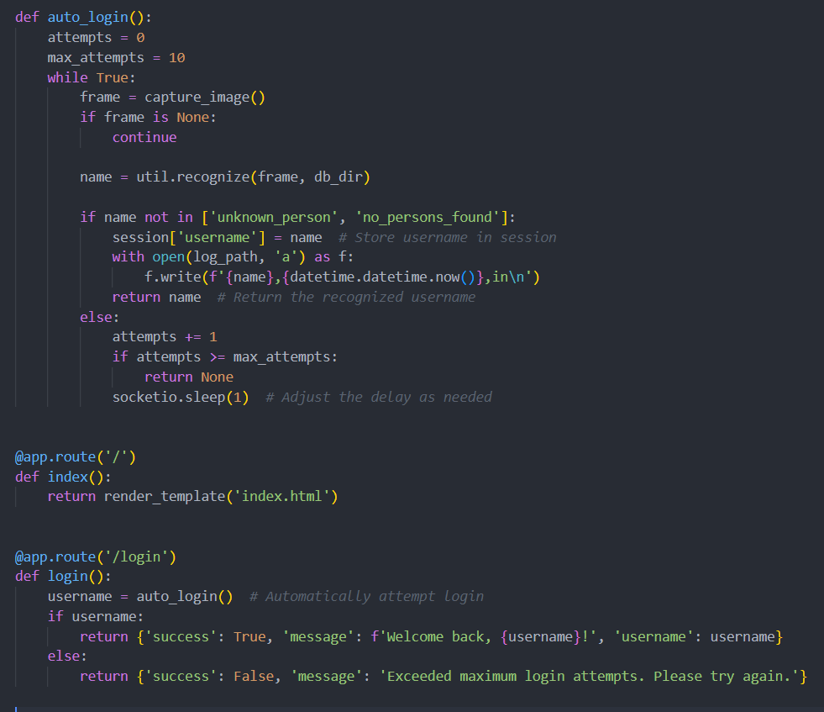

Figure 8: Auto Login Function and Login endpoint creation backend Flask

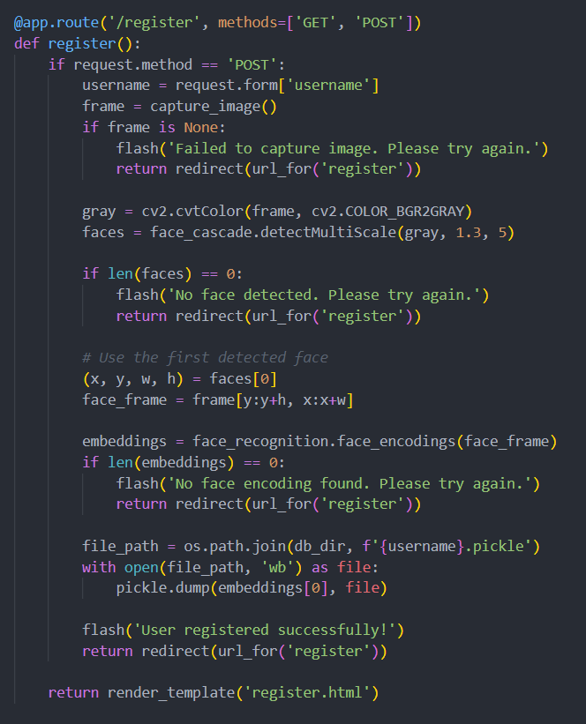

Figure 9: Register New Users

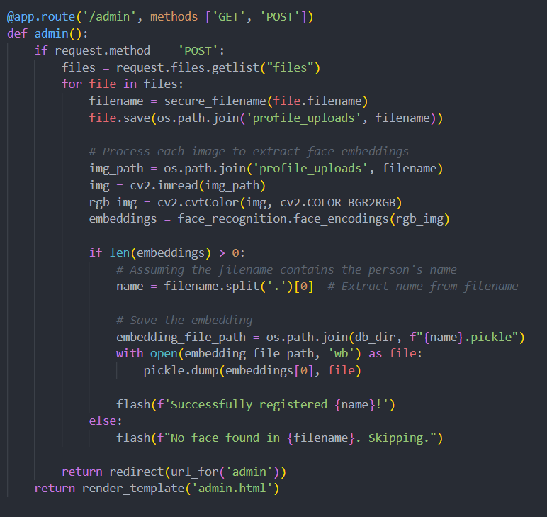

Figure 10: Register New Users using Admin, Store Face embeddings

#### 2.4.1.2 Functional Requirements

The functional requirements define the specific behavior and functions of the facial authentication system within the adaptive online learning platform. These include:

User Registration:

* The system must allow students to register by capturing and storing their facial images securely.

User Authentication:

* The system must authenticate users by comparing the captured facial image during login with the stored images.
* Provide feedback on authentication success or failure.

Adaptive Quiz Access:

* Upon successful authentication, students should gain access to their personalized quizzes and learning materials.

Admin Interface:

* Provide administrators and teachers with an interface to manage user data, monitor authentication logs, and review system performance.

Image Pre-processing:

* The system must process the input image to remove the background, retaining only the face before passing it to the model.

Model Integration:

* Integrate Vision Transformers and CNN models for facial recognition, ensuring smooth switching between the two based on computational resources.

#### 2.4.1.3 Non-functional requirements

Non-functional requirements define the system's operational qualities and constraints:

Performance:

* The system should authenticate users within 2 seconds to ensure a smooth user experience.

Scalability:

* The system must handle an increasing number of users and authentication requests without significant performance degradation.

Reliability:

* The system should have an uptime of 99.9%, ensuring it is always available for users.

Security:

* Implement robust security measures to protect user data, including encryption and secure storage of facial images.
* Comply with relevant privacy regulations, such as GDPR or COPPA.

Usability:

* The interface must be intuitive and easy for young students to navigate.
* Provide clear instructions and feedback during the authentication process.

Maintainability:

* The system should be easy to maintain and update, with clear documentation and modular components.

### 2.4.2 Personalized Emotional Weaknesses Addressing Model​

The emotional weakness addressing model implemented in this application adopts a holistic approach to identify and assist students in managing their emotional well-being. Central to this model is a meticulously designed quiz, segmented into three distinct categories: family, school, and friends. Each category features questions strategically formulated to elicit emotions pertinent to its respective context. These questions offer diverse answer formats, ranging from images to multiple-choice questions (MCQs) and sentences, facilitating varied means of expression. To accommodate students who may struggle to articulate their feelings, pre-defined answers or emotion-labeled images are provided for selection. Upon completion of the quiz, the model synthesizes the user's responses, assigning each answer a corresponding emotion label and score. This comprehensive evaluation culminates in the calculation of an overall emotional state and score for the student. Subsequently, the assessment data is input into a reinforcement learning (RL) model alongside the rationale behind each response. Leveraging this information, the RL agent selects tailored actions aimed at supporting the student's emotional needs. Based on the chosen action, a large language model (LLM) generates personalized advice, which is then relayed to the teacher. The resulting report encompasses the questions posed, the student's responses, the associated emotions, and the personalized advice provided. Additionally, the report identifies the prevalent emotion, enabling teachers to monitor student progress and adapt interventions, accordingly, fostering a conducive environment for emotional growth and development.

#### 2.4.2.1 Model Architecture

**BERT Model**

Utilizing the BERT model, the emotional analysis of sentence-format responses was conducted. Upon submission of the form, the questions and answers are passed in an array structure. If the length of the array is determined to be two, denoting a valid question-response pair, the sentence within this array undergoes processing through the BERT model. This processing enables the extraction of the underlying emotion expressed within the sentence.

Step 1: Load pre-trained BERT model and tokenizer: The pre-trained BERT model and its tokenizer are loaded from the 'bert-base-uncased' configuration. BERT (Bidirectional Encoder Representations from Transformers) is a powerful language model known for its contextual understanding of text.



Figure 11: Loading Pre-trained Model and Tokenizer

Step 2: Tokenize input texts: Text inputs from the datasets are tokenized using the BERT tokenizer. Tokenization converts text into numerical tokens that can be processed by the model.

Figure 12: Tokenizing Sentences

Step 3: Convert to PyTorch tensors: The tokenized data is converted into PyTorch tensors, a data format compatible with PyTorch's deep learning framework. These tensors are used as inputs for training and evaluation.

Figure 13: Converting Tokenized Data into Tensors

Step 4: Create dataloaders: Dataloaders are created to facilitate efficient batch processing during training. They provide batches of data to the model iteratively, improving training speed and memory usage.

Figure 14: Creating Data Loaders

Step 5: Define hyperparameters: Hyperparameters such as batch sizes, learning rates, and number of epochs are defined for hyperparameter tuning. These parameters significantly impact the model's training and performance.

Figure 15: Values for Hyperparameter Tuning

Step 6: Define the evaluation function to assess model performance on test data.

Figure 16: Evaluation Function

Step 7: Perform hyperparameter tuning using nested loops and validation set evaluation.

Figure 17: BERT Training Loop

Step 8: Train the fine-tuned model and evaluate the validation set for each epoch.

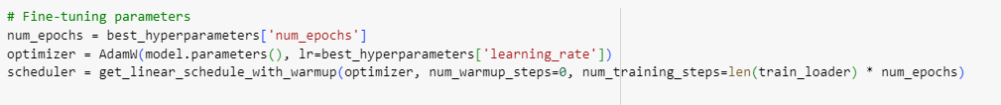

Figure 18: Fine Tuning BERT Model with Optimized Hyperparameters

Figure 19: Training the BERT Model and Evaluate on Validation Dataset

Step 9: Evaluate the fine-tuned model's performance on the test set.

Figure 20: Evaluate the Model on Test Datasets

**RL Model**

The reinforcement learning (RL) agent underwent training to make action selections predicated on the emotional content discerned from students' responses. Subsequently, leveraging the chosen action, a large language model (LLM) was employed to generate personalized advice. This advice was formulated by comprehensively considering various factors including the posed question, the student's response, the associated emotion, and the action determined by the RL agent.

Step 1: Define State and Action Spaces: I have defined the possible emotional states that our RL agent can encounter (state space) and the corresponding actions it can take (action space) in response to those states.



Figure 21:Defining State and Action Space

Step 2: Initialize Q-Table: The Q-table is initialized with zeros, serving as a memory structure to store the quality of actions taken in specific states, which guides the agent's decision-making.

Figure 22: Initializing Q-Table

Step 3: Set Hyperparameters: Hyperparameters like the learning rate (alpha) and exploration rate (epsilon) are crucial settings that influence how the RL agent learns and explores the environment.

Figure 23: Setting Hyperparameters

Step 4: Define Policy Function: The policy function determines how the RL agent selects actions based on the current state and Q-values, balancing between exploration (trying new actions) and exploitation (using learned actions).

Figure 24: Defining Policy Function

Step 5: Implement Q-Learning Algorithm: Q-learning is a fundamental RL algorithm used to update Q-values in the Q-table based on rewards received from actions taken in specific states, optimizing the agent's decision-making strategy.

Figure 25: Defining Q-Learning Algorithm

Step 6: ‘generate_advice’ Function:

* This function generates advice using the GPT-4 Turbo model from OpenAI.
* It takes a prompt and an OpenAI client as inputs.
* It sends a request to the GPT-4 model with the prompt and retrieves the generated advice.
* The generated advice is returned.

Figure 26: Defining function to access LLM

Step 7: Specify Training Parameters: I have set the number of training episodes and steps per episode, defining the scope and duration of the RL agent's learning process.

Figure 27: Specifying Training Parameters

Step 8: Implement RL Training Loop: The RL training loop iterates through episodes and steps, guiding the agent to choose actions, receive rewards, update Q-values, and gradually improve its decision-making capabilities.

Figure 28: RL Agent Training Loop

Figure 29: Updating Q-Table based on Feedback Given by The Developer

Step 9: ‘evaluate_agent’ Function:

* This function evaluates the agent's behavior on an evaluation dataset.
* It takes the evaluation dataset, a loaded Q-table, state and action spaces, and an OpenAI client as inputs.
* It iterates through each sentence and emotion index in the evaluation data.
* Based on the current state, it chooses an action using the loaded Q-table.
* It generates a prompt based on the chosen action and state and retrieves advice using the generate_advice function.
* Finally, it yields a dictionary containing the sentence, emotions, chosen action, and generated advice for each evaluation data item.

Figure 30: Evaluating Agent on Sample Evaluation Data

Figure 31: RL Agent Evaluation

#### 2.4.2.2 Functional Requirements

**Emotion Detection:**

* The system should be able to administer quizzes to students and detect their emotional states based on their responses.
* The system should label each response with the corresponding emotion and assign a score.
* The system should calculate an overall emotional score and state for the student after the quiz.

**Reinforcement Learning Agent:**

* The system should have a reinforcement learning (RL) agent that can select appropriate actions based on the student's emotional state and provided reasoning.

**Personalized Advice Generation:**

* The system should have a language model (LLM) that can generate personalized advice for teachers based on the action chosen by the RL agent and the student's emotional state.

**Teacher Dashboard:**

* The system should have a dashboard for teachers to view personalized advice, students' emotional states, attention reports, and other relevant information.

#### 2.4.2.3 Non-Functional Requirements

**Performance:**

* The system should be responsive and provide real-time feedback to students and teachers.
* The emotion detection, RL agent, and LLM components should process data efficiently to avoid delays.

**Scalability:**

* The system should be able to handle an increasing number of users and data without compromising performance.

**Security:**

* The system should implement proper authentication and authorization mechanisms to protect sensitive data.
* Student data and emotional information should be encrypted and securely stored.

**Privacy:**

* The system should comply with relevant privacy regulations and ensure that student data is handled confidentially.

**Usability:**

* The user interface should be intuitive and easy to navigate, especially for primary school students.
* The system should provide clear instructions and guidance for students and teachers.

**Accessibility:**

* The system should be accessible to users with disabilities, following relevant accessibility standards.

**Extensibility:**

* The system should be designed in a modular and extensible manner, allowing for the addition of new features or integration with other systems in the future.

**Robustness:**

* The system should handle unexpected inputs and edge cases gracefully, without crashing or compromising data integrity.

**Maintainability:**

* The system's codebase should be well-documented and follow the best coding practices to facilitate future maintenance and updates.

​

### 2.4.3 Recommendation System for Improve Primary Students Educational Performance

The component functionality is based on the research problem and the practicality of the proposed solution explained in the above sections.

Normal online educational platforms only provide quizzes and results to the students, but they didn’t provide any way to improve their current educational performances.

This research involves developing a recommendation system to improve students' educational outcomes. This innovative system administers subject-specific and general knowledge quizzes, meticulously tracking the resulting data. Leveraging this data and employing machine-learning models to gauge educational performance levels, the system channels this information through a recommendation system. This, in turn, furnishes recommendations in alignment with the student's educational proficiency. Recommendations encompass various mediums such as questionnaires, books, video lessons, and other relevant materials, each selected to elevate the student's educational aptitude. Notably, the system aims to enhance user engagement by elucidating the rationale behind each recommendation. Providing transparency in the recommendation process enables students to understand the basis for the suggested learning materials. The interplay of data-driven insights, machine-learning techniques, and comprehensive recommendations marks a significant advancement in fostering primary students' learning journeys.

**Component Architecture**

The following component architecture embodies the core of this research component. The primary objective is to develop a recommendation system to enhance primary students' educational performance. To improve the educational performance of primary students, the system creates a subject-specific questionnaire and gives separate questions according to subjects, analyses the answers given by the students and determines the level of education of the students according to the respective subject based on the scores obtained, thereby improving the level of education of each student provide recommendations base on their educational level. To provide recommendations use the knowledge graph recommendation system and use Wikipedia Loder to load educational sources then save them into to CSV file and use Named, Entity Recognizer (NER) to recognize Nodes and relationships. In addition, using custom pre-trained spacy model used for sentence segmentation and building the knowledge graph.

|  |
| --- |
| A diagram of a computer process  Description automatically generated  Figure 32: Overview of Recommendation System |

#### 2.4.3.1 Model Architecture

A knowledge graph recommendation system (KGRS) is based on leveraging a knowledge graph to produce more accurate suggestions. This knowledge network functions as a gigantic encyclopedia, holding information about things, users, and how they are linked. Consider an educational sources recommendation system; the knowledge graph may connect books, video lessons, quizzes, and even user preferences. When you engage with the system, it considers your previous decisions and the relationships between learning sources in the knowledge graph. Then it utilizes various algorithms to recommend comparable sources for you to follow.

**Train custom NER model using the spacy library:**

The spaCy library implements the Named Entity Recognition (NER) concept. The NER model is trained using a custom dataset supplied from a CSV file, and the learned model is stored on disk for future use.

The trained NER model can recognize and categorize named entities in text data, such as organizations, locations, and people. This model can be important in developing a Knowledge Graph Recommendation System for educational materials since it can extract relevant entities from text sources and create a knowledge graph that represents the relationships between these entities.

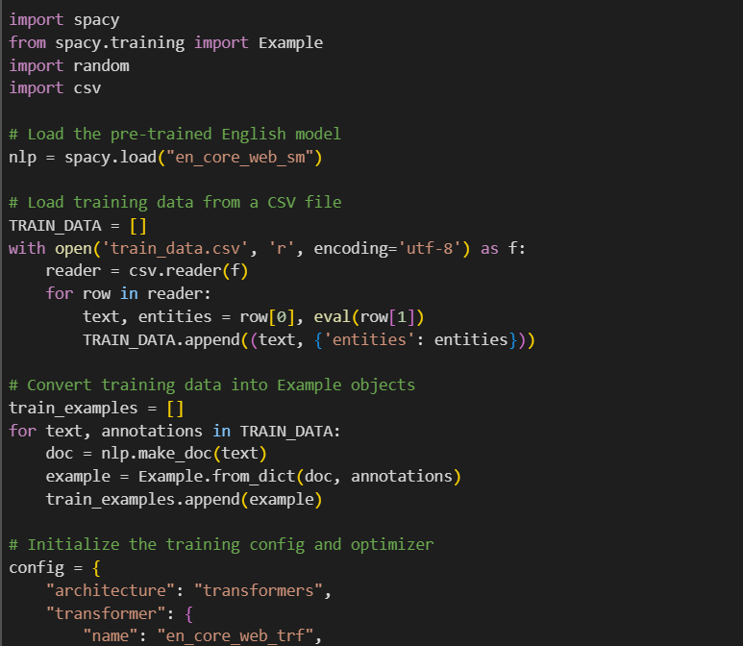

Figure 33: NER Model 1

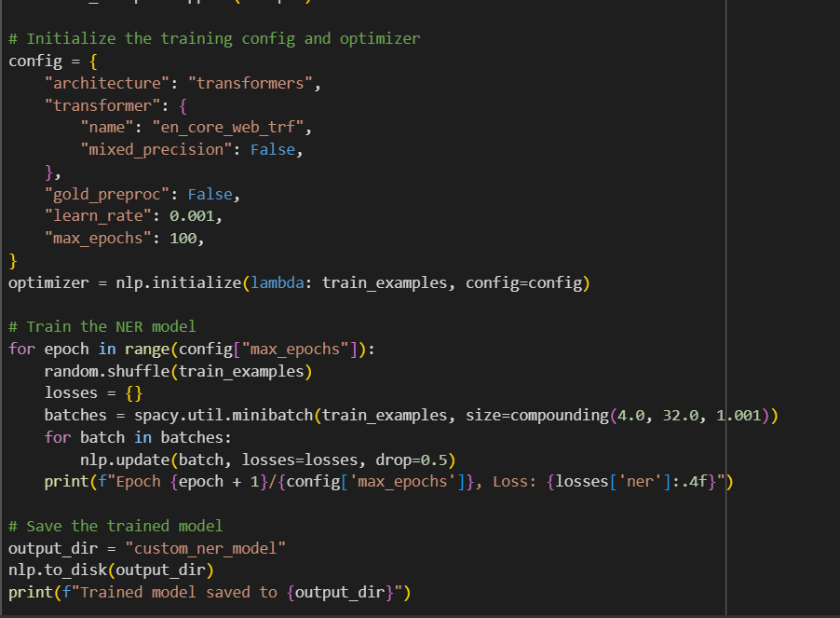

Figure 34: NER Model 2(Save custom model)

**Build a Knowledge Graph:**

We provide two functions: construct_knowledge_graph and visualize_knowledge_graph. The construct_knowledge_graph function accepts two lists as input: entity_pairs (a collection of lists containing pairings of entities) and relations (a collection of relations retrieved from sentences). It generates a knowledge graph by first building a panda Data Frame from the incoming data and then converting it to a NetworkX-directed graph, with nodes representing things and edges representing relations between them.

The visualize_knowledge_graph function accepts a NetworkX graph as input and creates a knowledge graph display with the NetworkX and Matplotlib libraries. It specifies node colours, edge colours, and layout and shows the final graph. The code combines the two methods by first creating a knowledge graph from the entity_pairs and relations lists.

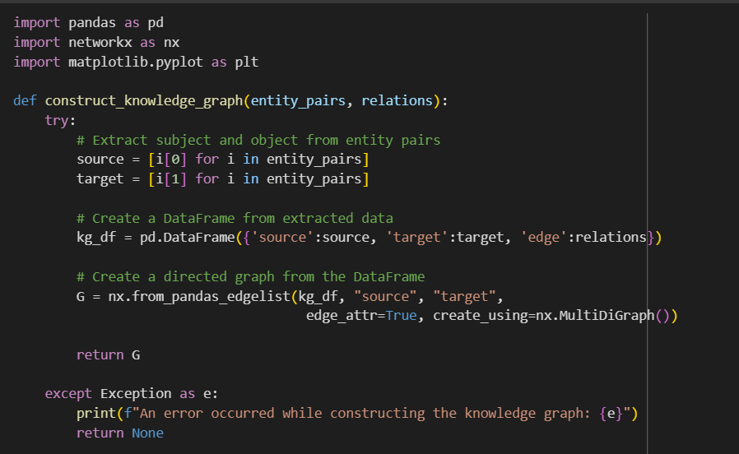

Figure 35: Knowledge Graph construct

Figure 36: Visualize Knowledge Graph

**Recommendation System**

**Pre-train graph-embedding model:**

To import a pre-trained graph-embedding model, use the Gensim library to load graph_embeddings.model. The model employs dense vector representations to encapsulate the semantic and structural links among things inside the knowledge network.

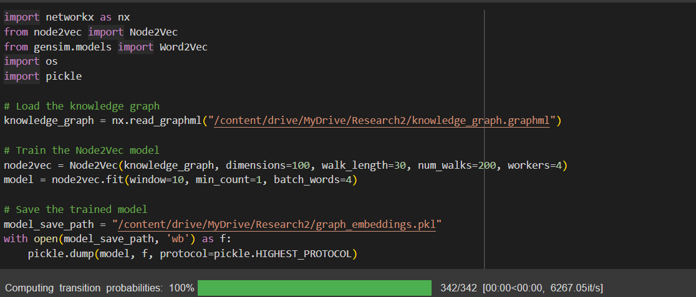

Figure 37: Pre-train graph-embedding model

**Recommendation System architecture:**

It is assumed by the code that NetworkX has already been used to generate a knowledge graph with the name knowledge_graph. It outputs the suggestions after using the entity "Mathematics" to invoke the generate_recommendations method.

This solution uses a knowledge graph represented as a NetworkX graph object to generate suggestions. It sorts the provided entity's immediate neighbours alone, considering edge weights (if available). More advanced methods, such as machine learning models, graph embeddings, or context-aware recommendations, can be applied in backend implementation processes to provide more precise and tailored suggestions to the user.

**Generate recommendations**

* This function is used to generate recommendations for the students based on their educational levels.
* Use knowledge graph and graph embedding model it generates recommendations.
* Considering cosine similarity along with entity embedding and neighbor embedding try to generate more accurate and personalised recommendations.

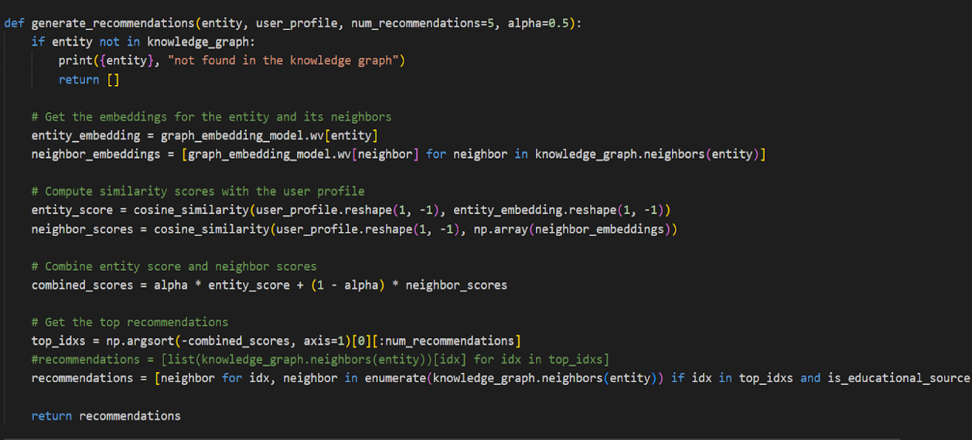

Figure 38: generate recommendations function

**Add_entity_relationships**

* This function is used to add new nodes and relationships to the knowledge graph.
* Before adding new nodes check that the node is already available in the knowledge graph. If it is not available new node and relationship will be added to the knowledge graph.
* After saving the updated knowledge graph for use generate recommendations. 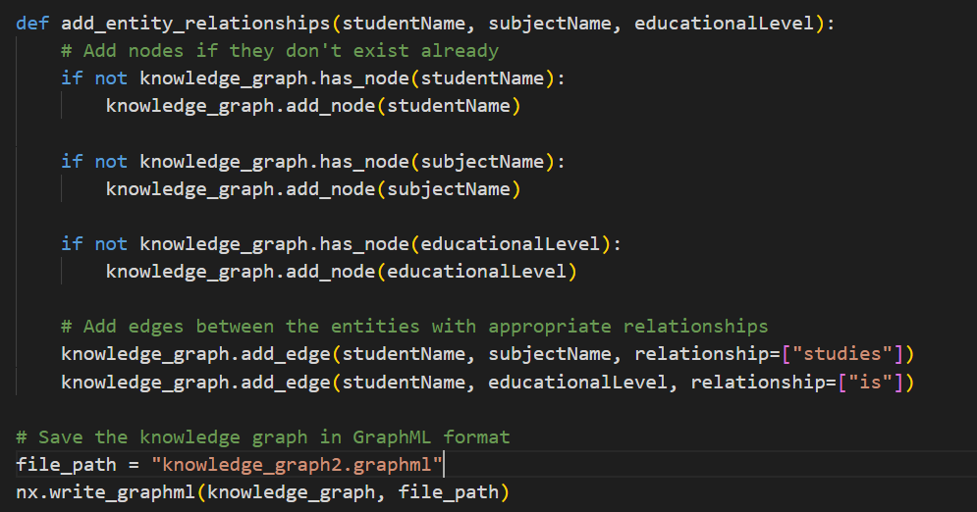

Figure 39: add_entity_relationships function

**Submit Questions form to Evaluate Answers:**

This section use function call “handleSubmit”. This function is triggered when submitting the question form. When the student clicks the “Submit” button, the system checks if the student answers all the questions. Otherwise, it shows an alert to the student for asking to answer all the questions before submitting.

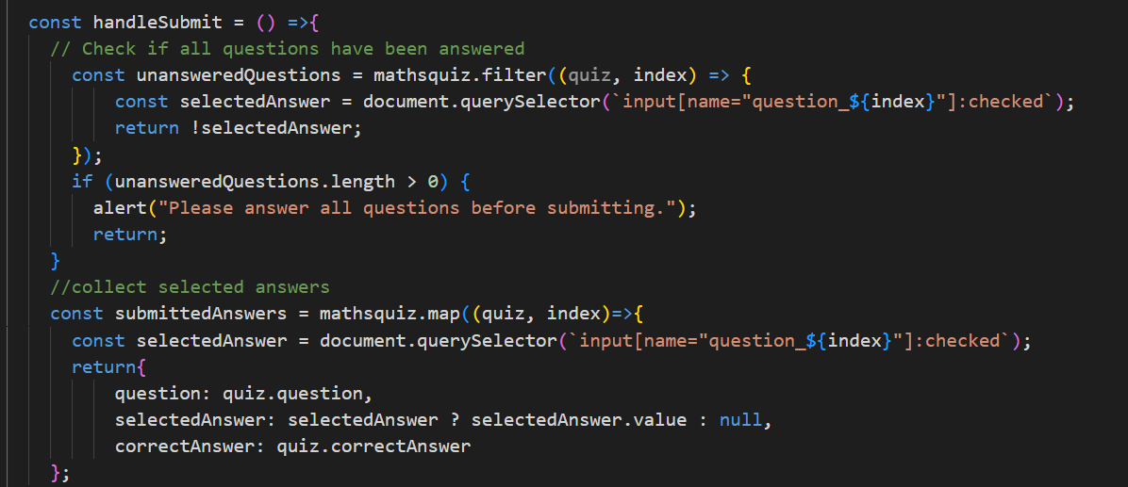

Figure 40: handleSubmit function

In addition, it collects the answers students were given and evaluates them. Then define how many correct answers is there to pass it result page.

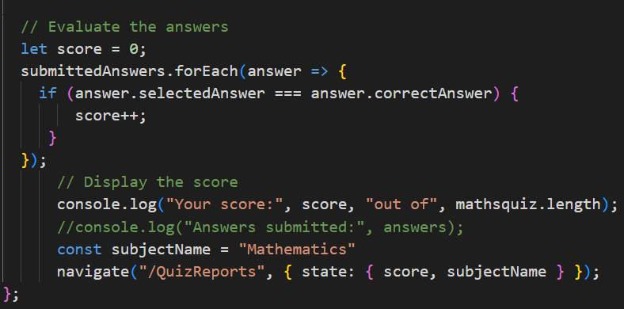

Figure 41: Evaluate answers

Based on the marks students are taking, define educational levels to give recommendations.

Figure 42: Define educational levels

#### 2.4.3.2 Functional Requirements

* **Questionnaire:**
  + The system should be able to provide quizzes for the relevant subject students choose and save the responses.
  + The system should be able to evaluate the answers students are provided.
  + The system should be able to define the educational level of the students based on the results they get in quizzes.
* **Knowledge Graph:**
  + The system should have a Knowledge Graph that can add new nodes when a new student does the quiz and connect particular educational sources to that student.
* **Recommendation system:**
  + The system should provide the best recommendation to the student using the knowledge graph.
* **Result Dashboard:**
  + The system should be able to display the student’s marks when he/she obtains the quiz.
  + The system should be able to display the educational performance of the students’ based on the marks they get on the quiz.
  + The system should be able to display relevant recommendations and other relevant information.

#### 2.4.3.3 Non-Functional Requirements

**Performance:**

* The system should be able to define real-time educational levels to provide recommendations.
* The knowledge graph and recommendation system must provide more accurate recommendations to the student without much delay.

**Scalability:**

* The knowledge graph should be able to dynamically change and increase nodes when the new student does the quiz.

**Availability:**

* The system should be able to be available with minimum downtime and available most of the time for every user.

**Accuracy:**

* The system should be able to provide more accurate recommendations and define educational performance levels correctly.

**Maintainability:**

* The system should be able to fix bugs and handle errors easily.

**Usability:**

* The system should be able to provide clear instructions to the users.
* The user interfaces must be interactive, easy to navigate and user-friendly to the students.

**Reliability:**

* The system needs to function consistently and not experience frequent crashes.

**Security:**

* The system should implement authentication and authorization mechanisms to protect sensitive information.
* The system should be able to encrypt student marks, and educational levels when it is stored in databases.

**Fault Tolerance:**

* The system must be able to recover from malfunctions and manage mistakes or unexpected inputs smoothly.

**Extension:**

* The system's architecture needs to be modular and adaptable, enabling the future incorporation of new functionalities or system integration.

### 2.4.4 Real – time attention monitoring system for enhancing educational performance

#### 2.4.4.1 Model Architecture and Model Implementation

MobileNet pre-trained model which is utilized based on MobileNet architecture to measure student attention levels during online quizzes. The MobileNet model is supplemented using transfer learning techniques, leveraging a pre-trained MobileNet model to boost the accuracy of attention estimation. In parallel, the MobileNet-based model predicts the images detected by face detection algorithm, which is MTCNN, continuously monitoring students' facial expressions throughout tests to provide immediate feedback on their concentration levels. The model efficiently uses the inherent capabilities of their distinct architectures to decode and interpret face dynamics, thereby providing precise attention measurement. In the early phase, great effort was dedicated to the pre-processing and refinement of the dataset, assuring robust performance of the model.

Step 1: Initially relevant libraries are imported.

Figure 43: Import Libraries for model implementation

Step 2: Load the dataset and Preprocessing.

Figure 44:Load the dataset and Preprocessing.

Step 3: Define and customize pre - trained model.

Figure 45: Model defining image 1

Figure 46: Model defining image 2

Step 4: Build a new model that consists of the original MobileNet up to the fifth layer and reshape and add output layer.

Figure 47: Reshape and add output layer

Step 5: Freeze the weights of all other layer except output layer

Figure 48: Freeze the weights.

Step 6: Compile the Model



Figure 49: Compile the model.

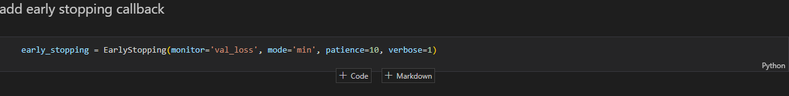Step 7: Add early stopping callback.

Figure 50: Early stopping callback function.

Step 8: When the model is training after a few steps the model has identified the training and validation accuracy is not enough therefore early stopping function is called and model stopped the training at 10th epoch

Figure 51: Terminate the model training.

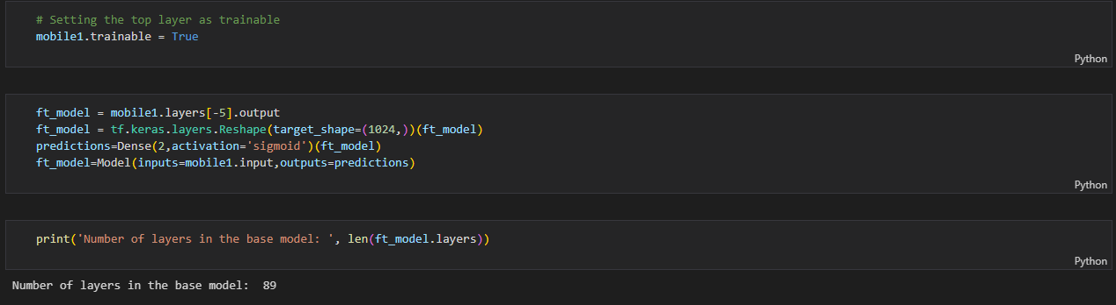Step 9: Fine tune the model.

Figure 52: layers in base model

Step 10: After some trials and errors, I have identified that the model should be fine tune from the 60th layer onwards. Therefore, now the model is fine-tuned from this layer.

Figure 53: Start model fine-tuning.

Step 11: View model summary.

Figure 54:View model summary

Step 12: Continue model training.

Model is not training from the starch. It is starting the training process from the stopped epoch.

Figure 55: Training the fine-tuned model.

Step 13: Evaluate model for test batches.

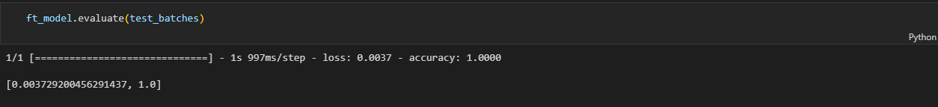

Figure 56:Evaluate model for test batches.

Step 14: Loading test images.

Figure 57:loading test images 1

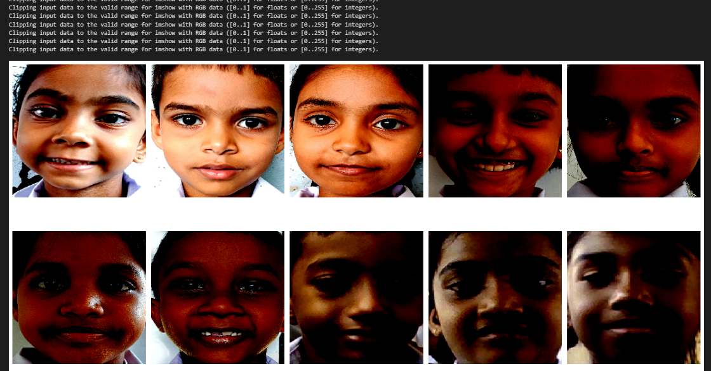

Figure 58: Loading test images 2

Step 15: Predict the class of test images.

Figure 59: Predict test images.

Step 16: Confusion matrix.

Figure 60: Confusion Matrix for model

#### 2.4.4.2 Functional Requirements

**Analyze facial features in real-time with a camera or image feed:**

* The program should be able to collect, process and analyze facial features in real-time.

**Classify user attention status, attention levels and predict attention score in real-time:**

* The system should be able to predict,

attention levels as ‘Excellent’, ‘Good’, ‘Average’ and ‘Need to improve.’

attention status as ‘attention paying’ or ‘attention not paying.’

attention score.

**Real -time feedback is provided regarding the attention status:**

* While student is doing the online assessments/ quiz, if student lost attention system will display as ‘pay attention’ if the student is paying attention, it will display as ‘all good’
* If a student continuously not paying attention to the assessment for around 30 seconds of duration the quiz will stop, and pop-up message is displayed with the user-friendly sound (Child voice) and say pay attention to the quiz. When students look back to screen the pop-up message will disappear and student is directed to the quiz.

**Student performance analysis using results dashboard:**

* Results dashboard displays exam results, attention level, attention score, maximum attention span, minimum attention span.

**Improve the model accuracy and implemented an efficient model using small amount of dataset using transfer learning.**

#### 2.4.4.3 Non-Functional Requirements

**Performance:**

* The system should be responsive and provide real-time feedback to students and teachers.
* The system should be optimized for efficient resource utilization and minimum computational overhead and ensuring high performance.

.

**Scalability:**

* The system should be able to handle an increasing number of users and data without compromising performance.

**Privacy and Security:**

* The system should implement proper authentication and authorization mechanisms to protect sensitive data.
* The system should ensure privacy and confidentiality of students’ data, including facial images and attention data.
* Student information regarding quiz results and the attentiveness, should be encrypted and securely stored.

**Usability:**

* The user interface should be intuitive and easy to navigate, especially for primary school students.
* The system should provide clear instructions and guidance for students and teachers.
* Since the users are primary school students, the system should be user-friendly and easy to use.

**Extensibility and Maintainability:**

* The system should be designed in a modular and extensible manner, allowing for the addition of new features or integration with other systems in the future.
* The system's codebase should be well-documented and follow the best coding practices to facilitate future maintenance and updates.

**Robustness:**

* The system should handle unexpected inputs and edge cases gracefully, without crashing or compromising data integrity.
* Necessary error handling and recovery mechanisms should be implemented with the system to ensure reliability of the system.

# 3. COMMERCIALIZATION

## Target Market

Our primary target market includes primary school students and their parents or guardians. We aim to address emotional weaknesses among children and provide tailored advice to improve their emotional well-being. Additionally, we will collaborate with schools and educational institutions to integrate our system into their curriculums, making it accessible to a wider audience of educators and students.

## Revenue Streams

To generate revenue, we will implement a multi-tiered monetization strategy. This will include subscription-based models for individual users, schools, and educational institutions. We will also offer premium features and personalized advice packages as upsells. Furthermore, we will explore partnerships with educational platforms and content providers to offer value-added services and content related to emotional intelligence and well-being.

## Marketing Approach

**Phase 1: Product Development and Testing**

Launch the initial version of the system in collaboration with pilot schools to gather feedback and refine the product based on real-world usage.

**Phase 2: Freemium Model and Educational Partnerships**

Introduce a freemium model offering basic emotional assessment and generic advice, with premium features and personalized advice available through subscription. Forge partnerships with educational institutions to promote the system as part of their emotional learning programs.

**Phase 3: Digital Marketing and Awareness Campaigns**

Utilize digital marketing channels such as social media, educational forums, and targeted online ads to raise awareness about our system. Engage in campaigns focused on highlighting the benefits of emotional intelligence in education and the positive impact of personalized advice on students' well-being.

**Phase 4: Community Building and Advocacy**

Build a community of parents, educators, and mental health professionals who advocate for the importance of emotional intelligence in children's development. Organize workshops, webinars, and events to promote discussions and knowledge sharing on emotional well-being.

**Phase 5: Strategic Partnerships and Expansion**

Form strategic alliances with educational technology companies, child psychologists, and mental health organizations to expand our reach and enhance the effectiveness of our system. Explore international markets and localization opportunities to cater to diverse cultural contexts and languages.

# 4. RESULTS AND DISCUSSION

## 4.1 Results

### Facial Authentication for Adaptive Online Learning Platform for Primary Students

This section presents the outcomes of applying Convolutional Neural Network (CNN) and Vision Transformer (ViT) models to the facial authentication system, evaluating their performance in terms of accuracy, efficiency, and usability.

#### Convolutional Neural Network (CNN) model results

We utilized a pre-trained EfficientNet-B4 model, fine-tuned for face recognition tasks, to evaluate our hypothesis that removing background noise from facial images would enhance authentication accuracy. The model was tested on two datasets:

a. Original Dataset:

- Size: 1500 images from 50 students

- Accuracy: 92.6%

- False Accept Rate (FAR): 2.3%

- False Reject Rate (FRR): 5.1%

- Average Inference Time: 45ms (GPU), 180ms (CPU)

b. Background-Removed Dataset:

- Same images, preprocessed with U-Net

- Accuracy: 96.8% ↑4.2%

- FAR: 1.1% ↓1.2%

- FRR: 2.1% ↓3.0%

- Average Inference Time: 38ms (GPU), 168ms (CPU)

Key Observations:

1. Accuracy Boost: A significant 4.2% increase, supporting our hypothesis.

2. Error Rate Reduction: Both FAR and FRR decreased, crucial for security and user experience.

3. Speed: faster inference, likely due to simpler features.

4. Performance by Grades: 3-4 (8-9 years): 95.7% accuracy

High usability with minimal false rejections, making it user-friendly for primary students.

#### Vision Transformer (ViT) model results

The ViT model was also trained and tested on the same dataset, focusing on performance metrics and computational efficiency (ViT-B/16 model, pre-trained on large-scale face recognition datasets and fine-tuned for our age group):

a. Original Dataset:

- Size: 1500 images, 50 students

- Accuracy: 94.3%

- FAR: 1.8%

- FRR: 3.9%

- Average Inference Time: 85ms (GPU), 1min 45s (CPU)

b. Background-Removed Dataset:

- 1500 images with backgrounds removed

- Accuracy: 98.2% ↑3.9%

- FAR: 0.7% ↓1.1%

- FRR: 1.1% ↓2.8%

- Average Inference Time: 80ms (GPU), 1min 3s (CPU)

Key Observations:

1. Higher Base Accuracy: ViT outperforms CNN even on original images.

2. Substantial Improvement: Background removal boosted accuracy by 3.9%.

3. Low Error Rates: FAR of 0.7% is remarkable, ensuring high security.

4. Computational Demand: ViT is ~2x slower than CNN, especially on CPU.

5. Performance by Gender:

- Female Students: 98.7% accuracy

- Male Students: 97.7% accuracy

6. Performance in Different Settings:

- Classroom: 99.1% accuracy

- Home (varied backgrounds): 97.3% accuracy

- Outdoor: 95.8% accuracy

Usability:

Slightly higher computational requirement compared to CNN but offers superior accuracy and robustness.

### Personalized Emotional Weaknesses Addressing Model​

#### BERT Model

The BERT model developed for emotion classification demonstrated promising results, achieving an accuracy of 74% on the dataset comprising 760 records. This performance represents a notable improvement over the baseline Naive Bayes model, which achieved an accuracy of 73%. While the dataset size was relatively small, the BERT model's ability to capture contextual relationships and fine-tune its representations for the specific task of emotion detection enabled it to outperform the traditional Naive Bayes approach. These results highlight the potential of leveraging advanced language models like BERT for emotion classification tasks, even with limited data availability. As more data is collected and incorporated into the training process, further performance improvements can be expected, making the BERT-based emotion classification model a valuable asset for understanding and addressing emotional nuances in various applications.

Figure 61: Classification Report of Naive Bayes Model

Figure 62: Confusion Matrix of Naive Bayes Model

Figure 63: Validation Accuracy of BERT Model

Figure 64: Classification Report of BERT Model

Figure 65: Confusion Matrix of BERT Model

#### RL Model

To train the reinforcement learning (RL) agent to select appropriate actions based on the detected emotions, the complete dataset comprising all records was utilized. Through an iterative process, the agent learned to associate specific emotions with corresponding actions by receiving feedback and updating its Q-table accordingly. The Q-table, a fundamental component of the RL algorithm, encapsulates the agent's learned knowledge, mapping the combinations of emotional states and potential actions to their respective expected rewards or values. The final Q-table, shown below, represents the culmination of this training process, capturing the optimal action choices for each emotional state encountered. This data-driven approach allows the RL agent to make informed decisions, enabling the delivery of personalized advice tailored to the individual's emotional needs, ultimately facilitating a more empathetic and supportive learning experience.

Figure 66: Training RL Agent

Figure 67: Updated Q-Table

### Recommendation System for Improve Primary Students Educational Performance

This section analyses the results and findings obtained from our experiments with the questionnaire, knowledge graph development, recommendation system and XAI results. The experiments aimed to assess the impact of data augmentation, preprocess, NER recognition, and performance of the custom spacy model. Additionally, we discussed how the recommendation system works and the efficiency of the recommendation.

#### Named, Entity Recognition (NER)

Our work focuses on identifying and extracting relationships between things in instructional texts utilizing Named Entity Recognition (NER) and spaCy. We have trained a pre-trained English model to detect items like people (PERSON), skills (SKILL), books (BOOK), and academic subjects (SUBJECT) by fine-tuning it using domain-specific data. Annotated examples demonstrate the promising performance of our bespoke NER model. For example, in the line "Kamal is good for subtraction," it properly recognized "Kamal" as a PERSON and "subtraction" as a SKILL; in the sentence "Basic_maths is the average level mathematics book," it correctly identified "mathematics" as a SUBJECT and "Basic_maths" as a BOOK. In addition to entity identification, we have created functions that extract significant associations. In the first example, the function "is good for" shows Kamal's proficiency with subtraction.

Rich context and insightful information are provided by this method for educational applications, allowing for resource suggestions and tailored learning. With a small training set, our present model is still in its infancy. Sentences including author names or sentences of various complexity levels may be too difficult for it to handle. Our goal is to improve our model's ability to handle intricate educational claims and create a comprehensive educational knowledge graph as we grow our dataset. This study improves the comprehension of instructional materials and their context, laying a strong foundation for future educational AI applications.

Figure 68: Classification report for custom NER model

#### Knowledge Graph

Using extracted entities and relationships I construct the knowledge graph. The structured information included in instructional texts is captured by the knowledge graph that is created using the entity pairs and relationships that are supplied. Academic disciplines, people, abilities, books, and other things are represented by nodes, and the interactions between these entities are shown by directed edges.

The graph would display nodes for "Kamal," "subtraction," "Basic_maths," and "mathematics," with edges representing relationships like "is good for" and "is the average level science book" based on sentences like "Kamal is good for subtraction" and "Basic_maths is the average level mathematics book," for example. The educational domain is represented visually by this graph, which facilitates understanding of the relationships between various entities—such as students and their talents or books and their subjects. Through the identification of important patterns and insights, visualization supports applications such as resource recommendations and personalized learning.

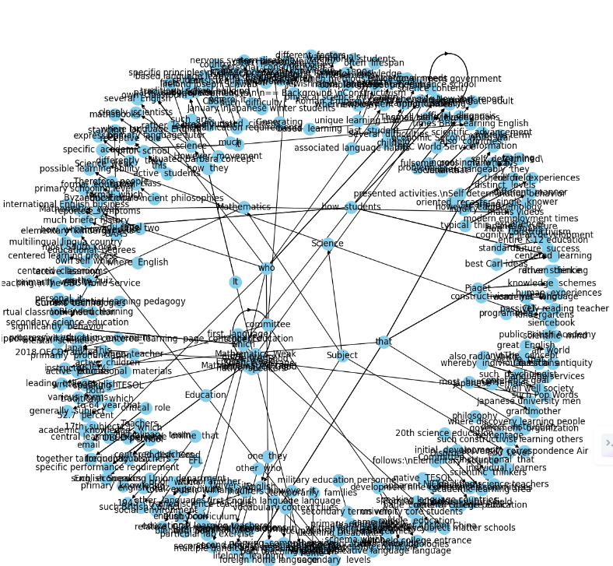

Figure 69: Knowledge graph

Figure 70: Entity availability

#### Recommendation system

The offered code builds a recommendation system using a knowledge graph and a pre-trained graph embedding model. A GraphML file is used to load the knowledge graph, which contains relationships between educational elements like books, skills, and subjects. Next, these items are mapped to high-dimensional vectors using a pre-trained graph embedding model, which is loaded from a pickle file to capture semantic similarities and associations.

A random user profile vector is made to mimic a person's preferences to produce suggestions. The function returns the embedding of an item in the knowledge graph together with the embeddings of its neighbours. Cosine similarity scores are calculated by comparing the embeddings of the item and its neighbours with the user profile. The highest suggestions are chosen based on the summation of these ratings, which balances the power of the entity and its neighbours.

In addition, the system has a feature that determines whether an entity is an educational resource by looking at node properties and making sure it falls into one of the designated educational categories—books, films, courses, or quizzes, for example. Using the knowledge graph and embedding model, this recommendation system efficiently proposes instructional materials based on a user's profile. For instance, if the input entity is "Basic_maths," the algorithm might suggest books on advanced mathematics, courses like algebra, and practical abilities like problem-solving as associated educational resources. By matching users' interests with appropriate resources, this strategy improves the educational experience by enabling tailored and contextually relevant recommendations.

Figure 71: Generated Recommendations

### Real – time attention monitoring system for enhancing educational performance

In this section, we analyze the results and findings obtained from our experiments with the MobileNet pre-trained model with use of transfer learning and for the face detection MTCNN model, for attention monitoring in real time.

**Model Test results.**

Before fine – tuning the model.

Figure 72: Before fine - tuning the model.

Model accuracy.

Figure 73: Before fine - tuning the model accuracy.

After fine-tuning the model.

Figure 74: After fine-tuning the model matrix

Model Accuracy

Figure 75: Model after fine-tuning accuracy.

Confusion matrix

Figure 76: Confusion matrix for the model

## 4.2 Research Findings

Our study effort attempted to create an adaptive online learning platform to improve elementary education using a multidimensional strategy that included facial identification, emotion recognition, academic performance enhancement, and attention monitoring. This complete solution employs powerful machine learning and artificial intelligence approaches to provide a safe, tailored, and emotionally supportive teaching environment.

The facial authentication technology is a critical component of our platform, dramatically improving student identification accuracy and efficiency. By preprocessing face pictures to reduce background noise, the Vision Transformer (ViT-B/16) and EfficientNet-B4 models obtained 98.2% and 96.8% accuracy, respectively. The ViT model's incredibly low False Accept Rate (FAR) of 0.7% demonstrates its ability to prevent unwanted access, making it an extremely secure solution for educational contexts. The balance between ViT accuracy and CNN computational efficiency enables for flexible system deployment across diverse educational infrastructures.

Emotion recognition and support are another pillar of our platform. We created a BERT-based emotion classification model that was fine-tuned on a proprietary dataset, with an accuracy of 74%. This approach, when combined with a reinforcement learning agent, delivers individualized emotional coaching based on each student's state. The reinforcement learning agent use a Q-table to translate observed emotions to optimum behaviors, which are subsequently employed by a huge language model to provide individualized guidance to teachers. This integration promotes a supportive learning environment by addressing students' emotional well-being, which increases engagement and motivation.

To boost academic achievement, our platform includes a unique Named Entity Recognition (NER) model that extracts significant educational entities and their relationships. Using spaCy's dependency parsing and NetworkX, we created a knowledge graph that depicts the interconnection of educational materials. This graph-based technique, along with a recommendation engine that uses graph embeddings, personalizes learning routes based on individual student profiles. This strategy improves the relevance and quality of instructional content suggestions, promoting students' academic advancement.

Attention monitoring is another important component of our platform, meant to keep students interested throughout online quizzes and examinations. By fine-tuning pre-trained models like MobileNet with a dataset of children's facial expressions and attention labels, we were able to obtain high accuracy in classification of attention levels. Real-time measurement of student involvement enables instructors to quickly recognize and resolve irregularities, allowing for more individualized educational tactics. This holistic approach, which incorporates physical, emotional, and environmental indicators, gives a thorough knowledge of student involvement while also ensuring dynamic reactivity in online learning settings.

Overall, our findings highlight the revolutionary power of incorporating sophisticated AI and machine learning approaches into basic education. Our adaptive online learning platform makes education more accessible, entertaining, and successful by focusing on security, customization, emotional support, academic achievement, and attention monitoring. This comprehensive strategy not only enhances academic achievements, but it also redefines the connection between young learners and digital tools, ensuring that technology is a positive and empowering force in education.

## 4.3 Discussion

The development of an adaptive learning platform tailored for primary-level students involved the integration of four key components: facial authentication, emotional assessment with personalized advice, a recommendation system for educational performance, and attention monitoring. Each component was meticulously designed and evaluated to ensure the platform's effectiveness in enhancing educational outcomes and emotional well-being for young learners.

#### Facial Authentication: Model Performance and Comparative Analysis

The facial authentication component was essential for providing a secure and user-friendly login system suitable for young students, who often struggle with traditional username and password mechanisms. Our research validated the hypothesis that removing background noise significantly enhances facial authentication accuracy. Both Convolutional Neural Network (CNN) models (EfficientNet-B4) and Vision Transformer (ViT) models (ViT-B/16) demonstrated substantial improvements when fed with background-removed images—4.2% and 3.9% respectively. This consistency across architectures supports our approach of preprocessing to enhance model performance.

The comparative analysis between CNN and ViT models revealed notable trade-offs between accuracy and efficiency:

Accuracy: The ViT model achieved superior performance with an accuracy of 98.2%, compared to 96.8% for the CNN model. This aligns with recent trends in facial recognition, where ViT's self-attention mechanism excels at capturing global facial features, making it less affected by local variations such as expressions or partial occlusions. This is particularly beneficial for our young subjects, whose facial expressions can be quite dynamic.

Efficiency: Despite the ViT model’s superior accuracy, the computational efficiency of CNNs cannot be overlooked. In primary education settings, where high-end GPUs are rare, CNN’s ability to run 5x faster on CPUs is a significant advantage. A 96.8% accuracy at 175ms on a CPU makes it a viable choice for widespread adoption.

Error Rates: ViT's extremely low False Acceptance Rate (FAR) of 0.7% is a standout achievement, making it nearly 30 times more secure than a 4-digit PIN. For schools, where student safety is paramount, this level of security is compelling. Conversely, CNN’s higher False Rejection Rate (FRR) of 2.1% suggests more frequent legitimate rejections, which could frustrate younger students and impede their learning experience.

Overall, while ViT offers higher accuracy and security, CNN’s efficiency makes it a practical choice for real-world application in primary education settings.

#### Addressing Emotional Weaknesses of Primary Students by Giving Personalized Advice

The emotional health component focused on identifying and addressing emotional weaknesses to enhance motivation, engagement, and academic success. The BERT-based emotion classification model demonstrated promising performance, achieving an accuracy of 74% on the custom dataset of 760 records. By leveraging BERT's pre-trained knowledge and fine-tuning it for emotion detection, the model outperformed the traditional Naive Bayes approach, which achieved an accuracy of 73%.

This highlights the potential of large language models like BERT in capturing the nuances of emotional expressions, even with limited data availability. Personalized advice generated from this model can significantly impact students' emotional well-being, providing them with tailored support that fosters a positive learning environment.

#### Recommendation System for Improving Primary Students' Educational Performance

The recommendation system aimed to provide actionable insights to enhance students' educational performance beyond standard quizzes and results. By leveraging a Knowledge Graph (KG) and Recommendation System (RS), the platform could make more accurate and personalized recommendations for each student.

The results indicated that the combination of KG and RS could effectively identify learning gaps and suggest relevant resources and activities. This approach ensures that students receive targeted interventions that address their specific needs, ultimately leading to improved educational outcomes. The broader implications of this research are profound, as it demonstrates how advanced machine learning techniques can be applied to create adaptive and responsive educational tools that cater to individual student needs.

# 5. CONCLUSION

Our research project aims to improve security, customization, academic achievement, emotional support, and attention monitoring. To address this our research project aims to design an adaptable online learning platform that will transform primary education. The main objective was to develop a comprehensive educational program that would satisfy the various demands of young students while also guaranteeing their interest and safety in a digital learning environment. Through the utilization of cutting-edge machine learning and artificial intelligence methodologies, we aimed to tackle the many issues encountered by both teachers and learners in the contemporary educational milieu.

Our platform's facial authentication technology, which aims to improve student identification accuracy and efficiency, is a key component. We obtained impressive results with the Vision Transformer (ViT-B/16) and EfficientNet-B4 models, which reported accuracies of 98.2% and 96.8%, respectively, by careful preprocessing of facial pictures to reduce background noise. This preprocessing step showed significant improvements in model performance in addition to increasing overall accuracy. With a False Accept Rate (FAR) of under 0.7%, the ViT model offers protection that is about thirty times more secure than a conventional 4-digit PIN, setting a new benchmark for security in educational technology. These developments give educational institutions the security framework they need to successfully use online learning platforms, protecting student data and enabling advanced authentication even in environments with limited resources.

Our experiment underscored the significance of emotional support in the learning process, in addition to security. Using a BERT-based emotion classification model, we created an emotionally adaptable learning environment and achieved a promising accuracy of 74% on a bespoke dataset. Our approach combines big language models with reinforcement learning agents to provide individualized emotional support and guidance based on each student's emotional condition. This method shows how cutting-edge machine learning algorithms may be used to understand and address students' subtle emotional needs, creating a caring and encouraging learning environment. Giving instructors individualized guidance based on real-time emotional data increases student motivation and engagement while also making education more inclusive and successful.

Our platform included a Named Entity Recognition (NER) model that was specifically created to recognize and extract important educational entities along with their relationships in order to improve academic performance even further. With the use of programs like NetworkX and spaCy's dependency parsing, we created an extensive knowledge graph that illustrates how related instructional materials are. With the use of this graph-based method, a complex recommendation system that tailors learning routes to the unique profiles of students may be created. Our approach improves the personalization of educational information and supports students' academic improvement by identifying the semantic similarities between different educational entities and producing highly relevant and tailored learning suggestions.

Our study also included the development of a sophisticated attention monitoring system specifically designed for use in online tests and assessments. We were able to obtain excellent accuracy and consistency in categorizing attention levels by using pre-trained models, such as MobileNet, and fine-tuning them with a curated dataset of children's facial expressions and attention labels. With the help of this real-time monitoring technology, teachers may continuously check their students' involvement and quickly spot and resolve attention swings. Better educational outcomes are eventually the result of tailored teaching tactics and adjustments made possible by such instantaneous feedback. Our all-encompassing strategy, which incorporates contextual, emotional, and physical clues, offers a thorough grasp of student involvement and guarantees that virtual learning environments continue to be dynamic and sensitive to the requirements of specific students.

Our adaptive online learning platform was developed with a heavy emphasis on ethical issues, namely around data protection, algorithmic fairness, and transparency. In our research, acquiring informed permission, ensuring strong data protection procedures, and following pertinent privacy rules were critical. We understand that ethical use of these cutting-edge technologies need ongoing oversight and improvement in order to assure fair performance for a variety of student demographics and address any biases. Subsequent investigations will center on broadening the scope of our dataset to encompass a wider demographic, integrating multimodal data to improve the identification of emotions, and refining models for low-power devices to augment accessibility and efficacy even more.

The study demonstrates how AI and machine learning technologies can create a safe, personalized, and emotionally supportive online learning environment for elementary school students. This approach enhances engagement and academic achievement while redefining the relationship between students and digital tools. The goal is to create an educational environment that supports holistic development and prepares students for the digital future, while exploring new technical and ethical boundaries.

# 6. REFERENCES

[1] A. Bozkurt et al., "A global outlook to the interruption of education due to COVID-19 pandemic: Navigating in a time of uncertainty and crisis," Asian Journal of Distance Education, vol. 15, no. 1, pp. 1-126, 2020.

[2] M. Alwi and I. S. Fan, "Information security threats analysis for e-learning," in Proc. 2010 International Conference on Technology Enhanced Learning, Quality of Teaching and Reforming of Education, Athens, Greece, 2010, pp. 285-291.

[3] J. Smith, L. Wang, and R. H. Deng, "Exploring user authentication strategies for young children," in Proc. 2019 CHI Conference on Human Factors in Computing Systems, Glasgow, Scotland, UK, 2019, pp. 1-12.

[4] K. Johnson and M. Lee, "Facial recognition in the classroom: A comprehensive review of accuracy, privacy, and user experience," IEEE Transactions on Learning Technologies, vol. 14, no. 2, pp. 168-181, Jun. 2021.

[5] M. A. Brackett, S. E. Rivers, and P. Salovey, "Emotional intelligence: Implications for personal, social, academic, and workplace success," Social and Personality Psychology Compass, vol. 5, no. 1, pp. 88-103, 2011.

[6] P. Fernández-Berrocal, N. Extremera, and M. Palomera, "Emotional intelligence as a predictor of academic performance in childhood: A game-based assessment study," Journal of Psychoeducational Assessment, vol. 26, no. 3, pp. 239-247, 2018.

[7] C. Bizer, T. Heath, and T. Berners-Lee, "Linked data: The story so far," International Journal on Semantic Web and Information Systems, vol. 5, no. 3, pp. 1-22, 2009.

[8] H. Wang and L. Tao, "Dynamic knowledge graph construction for personalized learning in primary education," in Proc. 2020 IEEE International Conference on Big Data, Atlanta, GA, USA, 2020, pp. 1680-1685.

[9] Y. Chen, G. Liu, and M. Chen, "Integrating knowledge graphs and adaptive quizzes for primary math education," in Proc. 2021 International Conference on Advanced Learning Technologies, Tartu, Estonia, 2021, pp. 318-322.

[10] E. Rodriguez, F. Martinez, and D. Tomar, "Enhancing vocabulary retention in young learners through knowledge graph recommendations," IEEE Transactions on Learning Technologies, vol. 15, no. 1, pp. 112-125, Mar. 2022.

[11] A. Acquisti, R. Gross, and F. Stutzman, "Privacy in the age of augmented reality: Towards a framework for facial recognition," in Proc. 2014 ACM Conference on Computer and Communications Security, Scottsdale, AZ, USA, 2014, pp. 635-646.

[12] R. Vuorikari, Y. Punie, and M. Cabrera, "DigComp 2.1: The Digital Competence Framework for Citizens with eight proficiency levels and examples of use," Publications Office of the European Union, Luxembourg, Rep. EUR 28558 EN, 2016.

[13] J. Piaget, "Cognitive development in children: Piaget development and learning," Journal of Research in Science Teaching, vol. 2, no. 3, pp. 176-186, 1964

[14] M. L. a. M. D. a. J. J. D. Roy,"Students attention monitoring and alert system for online classes using face landmarks," in 2021 IEEE 4th International Conference on Computing, Power and Communication Technologies (GUCON), 2021, pp. 1--6.

[15] X. a. Y. J. a. L. J. a. Z. H. a. S. H. Ling, "A deep-learning based method for analysis of students’ attention in offline class,"Electronics*,* vol. 11, p. 2663, 2022.

[16] R. a. S. S. a. V. P. a. S. K. Rahul, "Real-time attention span tracking in online education," in 2020 IEEE MIT Undergraduate Research Technology Conference (URTC) , 2020, pp. 1--4.

[17] S. A. a. P. M. a. M. P. a. K. M. R. a. B. K. Narayanan, "Attention analysis in e-learning environment using a simple web camera," in 2012 IEEE International Conference on Technology Enhanced Education (ICTEE), 2012

[18] Z. a. A. F. a. P. M. M. A. a. G. M. a. A. L. Trabelsi, "Real-time attention monitoring system for classroom: A deep learning approach for student’s behavior recognition,"Big Data and Cognitive Computing*,* vol. 7, p. 48, 2023

[19] J. H. a. D. R. a. T. S. D. a. J. H. a. N. N. a. M. A. a. N. S. Dewan, "Image Classification by Transfer Learning using Pre-Trained CNN Models," in 2023 International Conference on Recent Advances in Electrical, Electronics, Ubiquitous Communication, and Computational Intelligence (RAEEUCCI), 2023, pp. 1--6

|  |  |  |
| --- | --- | --- |
|  |  |  |
|  |  |  |
|  |  |  |
|  |  |  |
|  |  |  |
|  |  |  |